Design Document - Invoice Validation System

1. Problem Statement
Build a proof-of-concept invoice validation system that compares OCR-extracted invoice fields against ground truth and reference data, flags discrepancies, and outputs a validation status with a confidence score.

2. Data and Inputs
The system operates on three JSON sources:
- ground_truth.json: expected values for each invoice (labels).
- ocr_results.json: OCR-extracted values and confidence for each invoice (detections).
- database.json: reference data (purchase orders, vendor master, customer info).
Primary fields include vendor/customer name and address, PO number, invoice and due dates, amounts (subtotal, tax, total), and line items.

3. Data Overview and Challenges
- Missing OCR values occur most often in address fields.
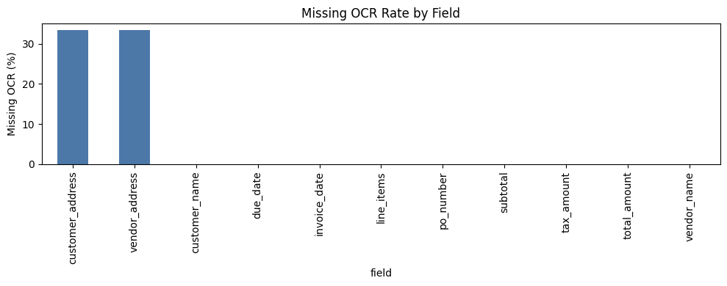
- Bounding box coverage is inconsistent across fields, so some highlights are placeholders.
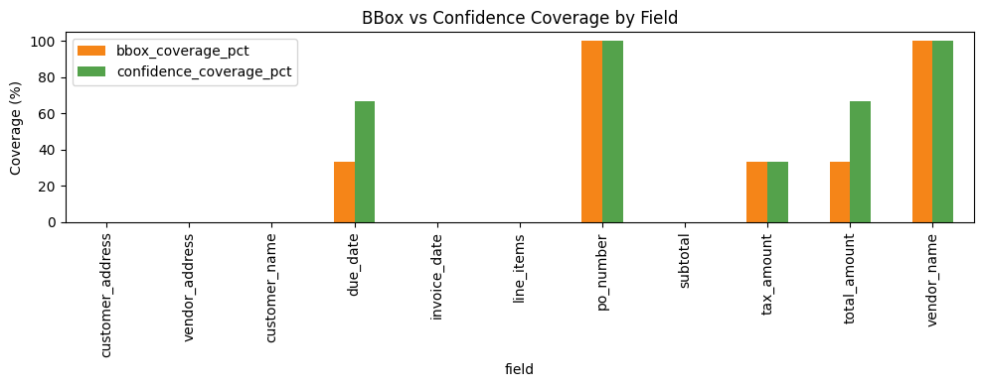
- Names and addresses are sensitive to truncation and abbreviations.
- Common OCR confusions: O/0, I/1/l, S/5, B/8.
- Dates can drift by 1 day; tax and totals can differ by small rounding errors.

4. Methodology
4.1 Pipeline
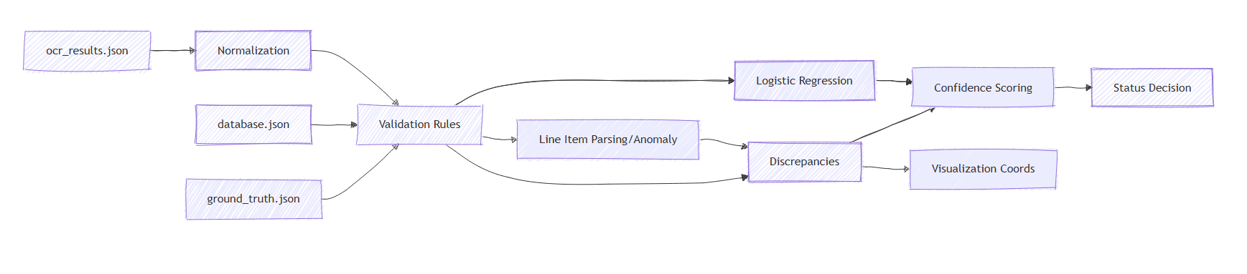
The diagram illustrates the processing pipeline: OCR data is normalized, compared with ground truth and the database to create discrepancies.
These discrepancies are used to calculate confidence and determine status; they also generate highlight coordinates for the final JSON output.
1. Data ingestion
- Read ground_truth.json, ocr_results.json, database.json.
- Basic schema validation to ensure required keys exist.
4.2 Normalization
- Lowercase, strip punctuation, and collapse whitespace.
- Normalize company suffixes (inc, llc, ltd, co).
- Normalize address abbreviations (street -> st, drive -> dr).
- Map OCR confusable characters for strict fields (O/0, I/1/l, S/5, B/8).
- Parse dates and amounts with tolerant parsing to handle format variants.
4.3 Field Validation Rules
- PO number: exact match after OCR-confusion normalization.
- Names and addresses: fuzzy similarity (token set + edit distance).
- Dates: 1-3 day drift -> warning, larger drift -> critical.
- Amounts: absolute and relative tolerance to allow small rounding differences.
- Tax: cross-check against PO tax_rate when available.
4.4 Line Items
- Parse line item text into description, quantity, unit price, and total.
- Item not in PO valid_items -> critical.
- Quantity above PO max_quantity -> critical.
- Line total mismatch -> warning.
4.5 Discrepancies, Confidence, and Status
- Discrepancy object includes field, issue_type, expected, detected, confidence, suggestion, and bounding box.
- Overall confidence combines OCR confidence with penalties from discrepancies.
- Status logic (POC): critical or warning -> needs_review; otherwise approved.

5. ML: Logistic Regression
A lightweight logistic regression model predicts the probability that a field is wrong. Features include OCR confidence, text length, digit ratio, fuzzy score, amount/date diffs, and field identity. The model output is used to calibrate confidence.

6. Outputs and Results
Sample outputs are saved in sample_outputs/*.json. Summary:
- INV-2024-001: status=needs_review, confidence=0.541, issues: PO confusion (PO-78910 vs P0-78910), customer_name truncation (Suri Tech).
- INV-2024-002: status=needs_review, confidence=0.085, issues: PO confusion (PO-4567B), missing customer_address, line_items[1].quantity mismatch (critical).
- INV-2024-003: status=needs_review, confidence=0.680, issue: missing vendor_address in OCR.

7. Tests
Pytest coverage includes 15 cases: missing fields, OCR confusion (O/0), date out-of-range, tax and amount tolerance, line item anomalies, and address abbreviation handling.

8. Assumptions and Limitations
- OCR output is structured and aligned to expected field names.
- Sample size is small; ML model is illustrative only.
- No real invoice images provided; visualization bounding boxes may be placeholders.

9. How to Run
python -m venv .venv
.\.venv\Scripts\Activate.ps1
python -m pip install -r requirements.txt
python .\scripts\run_demo.py
python .\scripts\generate_sample_outputs.py

10. Deliverables
- README.md (run instructions).
- Design Document.docx (this report) and DESIGN.md.
- Notebook: data_overview.ipynb.
- Sample outputs: sample_outputs/*.json.
- Source code: src/* and scripts/*.
- Tests: tests/*.

